Title of Manuscript

Author 1 ^{1*}; Author 2²; Author 3³; Author 4⁴; Author 5⁵
¹ Department, University, City, Country
² Department, University, City, Country
³ Department, University, City, Country
⁴ Department, University, City, Country
⁵ Department, University, City, Country

Article Info |  | ABSTRACT
Article history:  Received 1 March 2025  Revised 5 April 2025  Accepted 1 June 2025 |  | Abstract Instructions: The abstract must not exceed 200 words and should be written in Times New Roman, font size 10, with single line spacing and justified alignment. It should provide a concise overview of the study, including the purpose of the research, the methodology employed, the characteristics of the study sample, the main results, and the most significant recommendations or conclusions.  Keywords Instructions: Authors must provide between four (4) and six (6) keywords that best reflect the content of the study. Keywords should be written in Times New Roman, font size 10.
Keywords:
Intellectual intelligence
Emotional Intelligence
University
Students
الكلمات المفتاحية:  الذكاء الفكري  الذكاء الإنفعالي  الجامعة  الطلبة |  | ملخص
Abstract (Arabic): An abstract in Arabic must also be provided. It should not exceed 200 words and must be written in Simplified Arabic, font size 11, with single line spacing and justified alignment. The Arabic abstract should summarize the study purpose, methodology, sample, main results, and the most important recommendations or conclusions.
Keywords (Arabic): Authors must provide between four (4) and six (6) keywords in Arabic. The keywords should be written in Simplified Arabic, font size 11, with single line spacing.
Corresponding Author Instructions: The manuscript must clearly identify the corresponding author. The corresponding author should provide the full name (first, middle, and last name) and a valid email address. The corresponding author will be responsible for all communication with the journal, including submission, peer review, and publication processes.
* Corresponding Author:
Email: noor_azniza@uum.edu.my (N. Azniza)

Introduction
Main Headings Instructions: The research paper must include only the following main headings, numbered using Arabic numerals: (1 Introduction, 2 Methodology, 3 Findings, 4 Discussion and Conclusion). All headings should be written in Times New Roman, font size 12, in bold, and aligned to the left margin with no indentation. No additional main headings are permitted beyond these four.
Body Text Instructions: All paragraphs should be written in Times New Roman, font size 11, with single line spacing and justified alignment. The first line of each paragraph must begin with an indentation equal to two presses of the “Tab” key.
Subheadings Instructions: Authors may add subheadings under each main heading, numbered consistently with the corresponding main heading (e.g., 1.1 Objectives of the Study, 3.1 Arab Student's Emotional Intelligence Level). Subheadings must be written in Times New Roman, font size 12, in bold, and aligned to the left margin without indentation. If a third-level subheading is required, it should be written in Times New Roman, font size 12, in italics without numbering (e.g., Academic Levels).

Tables Instructions (APA 7th Edition):
Tables must be numbered consecutively (Table 1, Table 2, etc.) in bold, aligned to the left, with a clear italicized title in Title Case placed below the table number. Only horizontal lines are allowed: at the top, below the headings, and at the bottom (no vertical lines). Text inside tables should be in Times New Roman, font size 11, single spacing, and usually centered. Notes, if needed, appear below the table in Times New Roman, font size 10, including general notes, specific notes (using superscripts), and significance notes (e.g., p < .05). Tables must be clear, concise, and not duplicate content from the text or figures.

Table 1
Emtoional Intelligence Level
Variable Mean SD Level
Self-Awareness 2.95 .71 Moderate
Self-Regulation 2.78 .749 Moderate
Motivation 3.37 .682 High
Empathy 2.95 .761 Moderate
Social Skills 2.81 .711 Moderate
Emotional Intelligence 2.82 .591 Moderate
Figures Instructions (APA 7th Edition):
Figures must be numbered consecutively (Figure 1, Figure 2, etc.) in bold, aligned to the left. Each figure must have a clear title in italicized Title Case placed below the figure number (e.g., Figure 1
Conceptual Model of the Study). Figures should be simple, clear, and readable, using consistent font style (Times New Roman, size 11). Captions and labels must be concise and self-explanatory. Notes, if applicable, appear below the title in Times New Roman, font size 10, and can include general explanations, specific details, or significance notes. Figures must not duplicate information from tables or text but rather complement them.

Figure 2
Conceptual Model of the Study Variables
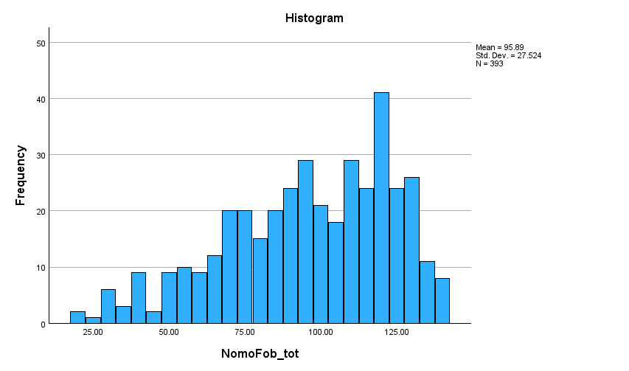

References Instructions (APA 7th Edition):
All references must follow the Publication Manual of the American Psychological Association (7th edition). The reference list should appear at the end of the manuscript on a new page, titled References (bold, centered). References must be double-spaced, with Times New Roman, font size 11, and justified alignment. Each reference should use a hanging indent of 0.5 inches (first line flush left, subsequent lines indented). Entries must be listed in alphabetical order by the first author’s last name.

References
Adeyemo, D. (2003). The buffering effect of emotional intelligence adjustment on the adjustment of secondary school students in transition. Electronic Journal of Research in Educational Psychology, (2), 79-90.
Elias, M.J., Zins. J.E., Weissberg, R.P., Frey. K.S., Greenberg, M.T., Haynes. N.M., Kessler, R., Schwab-Stone. M.E., & Shriver, T.P. (1997). Promoting social and emotional learning: guidelines for educators. Alexandria. VA: Association for Supervision and Curriculum Development.
Goleman, D. (1995). Emotional intelligence. Newyork; bantan books.

